**Jake Lorah**

**Computer Science 1**

**Mr. Mix**

**Digital Notes**

**2015-2016**

**Lesson 9/2/15:**

Objective: Learn about the 3 number systems and get introduced by vocab set 1.

* **Decimal System:** Base: 10

Range: 0-9

Example: 5

* **Binary System:** Base: 2

Range: 0-1

Example: 1001

* **Hexadecimal System:** Base: 16

Range: 0-1 and A-F

Example: 2A

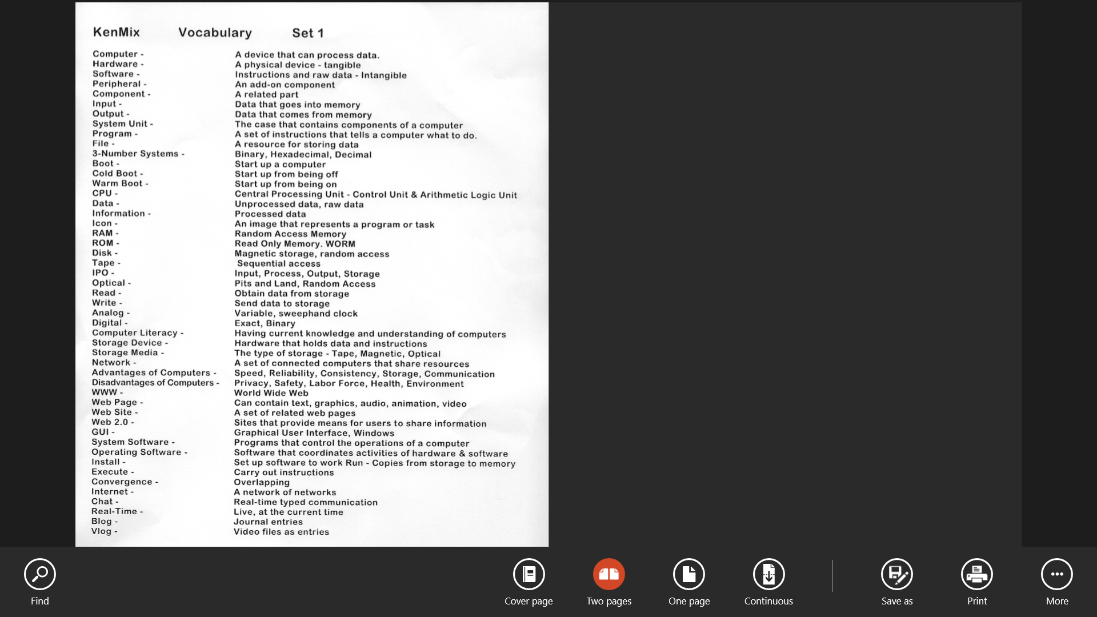

**Lesson 9/3/15:**

Objective: Learn more about Decimal, Binary, and Hexadecimal number systems and file structure.

|  |  |  |
| --- | --- | --- |
| **Decimal** | **Binary** | **Hexadecimal** |
| 0 | 0 | 0 |
| 1 | 1 | 1 |
| 2 | 10 | 2 |
| 3 | 11 | 3 |
| 4 | 100 | 4 |
| 5 | 101 | 5 |
| 6 | 110 | 6 |
| 7 | 111 | 7 |
| 8 | 1000 | 8 |
| 9 | 1001 | 9 |
| 10 | 1010 | A |
| 11 | 1011 | B |
| 12 | 1100 | C |
| 13 | 1101 | D |
| 14 | 1110 | E |
| 15 | 1111 | F |
| 16 | 10000 | 10 |

**American Standard Code for Information Interchange:**

A=65 a=97

B=66 b=98

C=67 c=97

**File structure:**

<!DOCTYPE html>

<html>

<head>

…….

</head>

</html>

**Lesson 9/4/15:**

Objective: Learn deeper into programing.

* <tag-name> means open

- </tag-name> means close

- Always save documents ending as .htm (ex: Lab1.htm)

- HTML 5 is a collection of technologies that have been brought under a single umbrella name.

**Operators:**

* Assignment: =
* Arithmetic: + - * / %
* % = Modulus (remainder)

**Example Code:**

<!DOCTYPE html>

<html>

<head>

<title>

</title>

</head>

<body bgcolor=yellow>

Jake Lorah

</body>

</html>

**Lesson 9/8/15:**

Objective: Learn about Truth Tables and symbols.

|  |  |
| --- | --- |
| **P** | **Q** |
| T | T |
| T | F |
| F | T |
| F | F |

* A truth table is a diagram in rows and columns showing how the truth or falsity of a proposition varies with that of its components.
* Heads – True1
* Tails – False 0
* U=or
* ∩=and
* ~=not or opposite of
* Analog is old
* Digital is new
* Ø=the # zero. We do this so we don’t get o’s and 0’s mixed up.

**Lesson 9/9/15:**

Objective: Get a little deeper into truth tables. Also discuss a little about pixels.

|  |  |  |  |  |  |
| --- | --- | --- | --- | --- | --- |
| **P** | **Q** | **~P** | **~Q** | **P∩Q** | **PUQ** |
| T | T | F | F | T | T |
| T | F | F | T | F | T |
| F | T | T | F | F | T |
| F | F | T | T | F | F |

* Color: Black means off and White means on.
* Pixel: 1 dot on the screen.
* **Red Green Blue** is all that is showing on the screen.

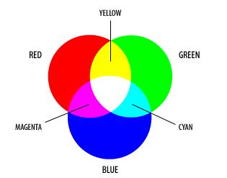

**Lesson 9/11/15:**

Objective: Learn about the 3 programming control structures and answer some questions.

**3 Programming Control Structures:**

1. Sequence.
2. Selection. Ex: If x then a else they b.
3. Iteration. Ex: Looping.

Question#1: What is the internet?

Answer: A network of networks.

Question#2: What services do the internet provide?

Answer: Email, communication, gaming, etc…

Question #3: How is a website designed, coded, tested, and implemented?

Answer: HTML, CSS, and Java Script.

Question #4: What is CSS?

Answer: Cascading Style Sheets makes the layout of the website.

Question #5: What is Java Script?

Answer: A scripted language that adds functionally to a website.

Question #6: What are the 3 programming control structures?

Answer: Sequence, Selection, and Iteration.

Question #7: Why is Java Script necessary?

Answer: To make a website productively. HTML doesn’t have that capability.

Question #8: What products are available in Adobe Creative Sweet?

Answer: Photoshop, Dream Weaver, and Flash.

**Lesson 9/14/15:**

Objective: Learn about Web Tables and how to code them.

Purpose of web tables: 1. To line up data.

2. Layout Control.

Row 1

|  |  |  |
| --- | --- | --- |
| X  Row 2 | X | X |
| Y | Y | Y |
| Z  Row 3 | Z | Z |

Column 3

Column 2

Column 1

**Code:**

<table border=1>

<tr height=100px>

<td>A</td>

<td>B</td>

<td>C</td>

</tr>

<tr height=150>

<td>D</td>

<td>E</td>

<td>F</td>

</tr>

</table >

**Preview:**

|  |  |  |
| --- | --- | --- |
| A | B | C |
| D | E | F |

**Lesson 9/15/15:**

Objective: Learn about Iteration.

* Iteration is when a process or sequence in a computer is repeated.
* X++ = Add 1
* X-- = Minus 1

**Code:**

<script>

for(x=0;**x<=9**;x++)

{

document.write(x);

}

Questions about the code above:

1. Change font for the Initialize.
2. **Bold** the Test.
3. Underline the Increment.

**Lesson 9/21/15:**

Objective: Learn about col span and row span in tables.

* Colspan and Rowspan are table cells that span across more than one column or row. The attributes COLSPAN ("how many across") and ROWSPAN ("how many down") indicate how many columns or rows a cell should take up.

Code: Results:

<table border=1>

|  |  |  |  |
| --- | --- | --- | --- |
| A | | B | |
| C | D | | E |
| F | G | | H |

<tr>

**<td colspan=2>A**

<td> B

</tr>

<tr>

<td> C

<td> D

<td> E

</tr>

<tr>

<td> F

<td> G

<td> H

</tr>

**Lesson 9/22/15:**

Objective: Learn about variables and arrays.

**Variable:**

* Variable: A symbol that represents a value.

Naming Rules for a variable:

* A-Z
* a-z
* 0-9
* -
* Must start with alpha.
* Must be unique.
* Cannot be a keyword.
* Length max=31.

**Array:**

* Vector, matrix, dimension, and table are other names for an array.

Rules for an array:

* Same data name.
* Same data type.
* Contiguous in Memory*.
* Fixed in length**.
* Access with a subscript.

Rules for each element in an array:

* Number.
* Value.
* Subscript.
* Hexadecimal address.

**Lesson 9/25/15:**

Objective: Learn about mean, median, mode, and range.

1. **Mean:** The “average” of a set of numbers. When you add all the numbers and then divide that number by how many numbers there are.

Example: 1, 2, 3, 4, 5. The mean here is 3 because 15/5=3.

1. **Median:** The middle number in a set of numbers. You must put the numbers from least to greatest before you find the median.

Example: 1, 2, 3, 4, 5, 6. The median here would be 3.5 because 3.5 is the middle number.

1. **Mode:** The number that occurs the most in a set of numbers.

Example: 1, 1, 2, 2, 2, 3, 4, 5, 6, 6. The mode here would be 2 because 2 occurs three times which is the most out of all numbers.

1. **Range:** Subtracting the biggest number by the smallest number from a set of numbers.

Example: 1, 2, 3, 4, 5, 6. The range here would be 5 because 6 – 1 = 5

**Lesson 9/28/15:**

Objective: Learn how to code the average and Standard Deviation:

**Code the average:**

var sum=o;

for(x=0;x<=9;x++)

{

sum=sum+a1[x];

}

document.write(“sum=”+sum);

document.write(“Average=”+(sum/10));

**Standard Deviation:**

* Standard Deviation is a quantity calculated to indicate the extent of deviation for a group as a whole.

1-3= -2 4

2-3= -1 1

3-3= 0 0

4-3= 1 1

5-3= 2 4

Variance: 2

Standard Deviance: 1.414

http: **H**yper**T**ext, **T**ransfer, **P**rotocol

Protocol: A rule.

ftp: **F**ile, **T**ransfer, **P**rotocol

**Lesson 10/1/15:**

Objective: Get introduced with vocab set 2.

**Page 1:**

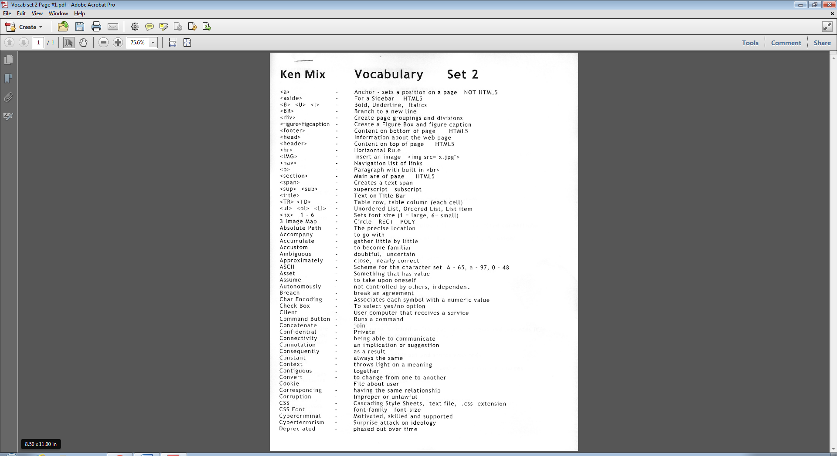

**Page 2:**

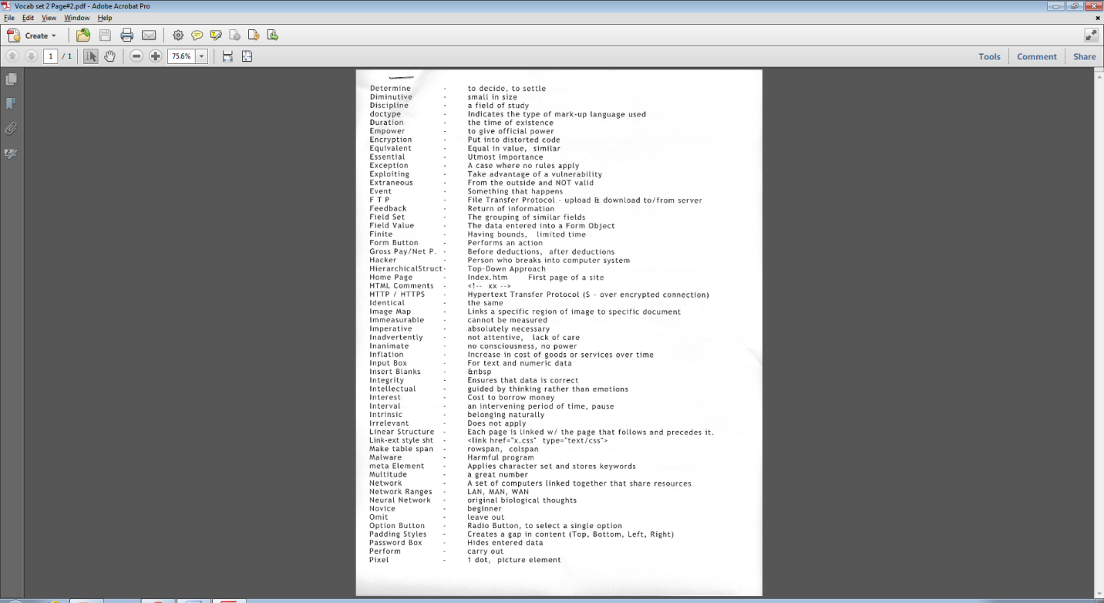

**Page 3:**

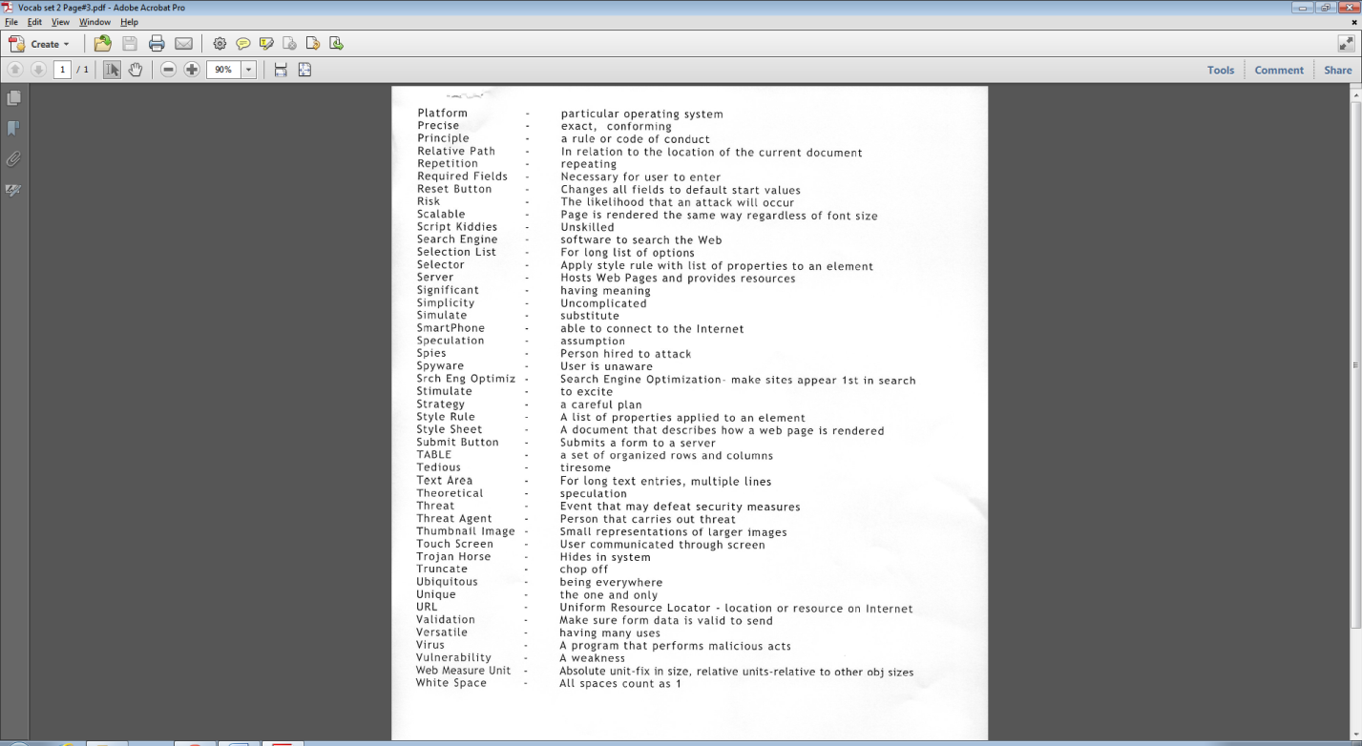

**Lesson 10/27/15:**

Objective: Learn a few things from Dreamweaver.

**To create a hyperlink:**

1. Select the word/phrase/image that you would like to give a hyperlink to.
2. Click insert and then hyperlink.
3. Type in the link section the url where you want to go.
4. Then choose target _top.
5. Click enter.

**Insert an image:**

1. Click where you want the image to be.
2. Click insert. Then image.
3. You can change the height and width on the bottom of Dreamweaver.

**Background color:**

1. Modify- Page Properties.
2. Select Bgcolor.
3. Apply

**Lesson 12/21/15:**

Objective: Learn a few things from Microsoft Access

* When designing a table in Microsoft Access, make sure…

1. Primary Key is ID column.
2. SQL Statements must end with a ;

* All of the SQL main statements are…

1. SELECT
2. FROM
3. WHERE
4. ORDER BY

**Lesson 1/4/16:**

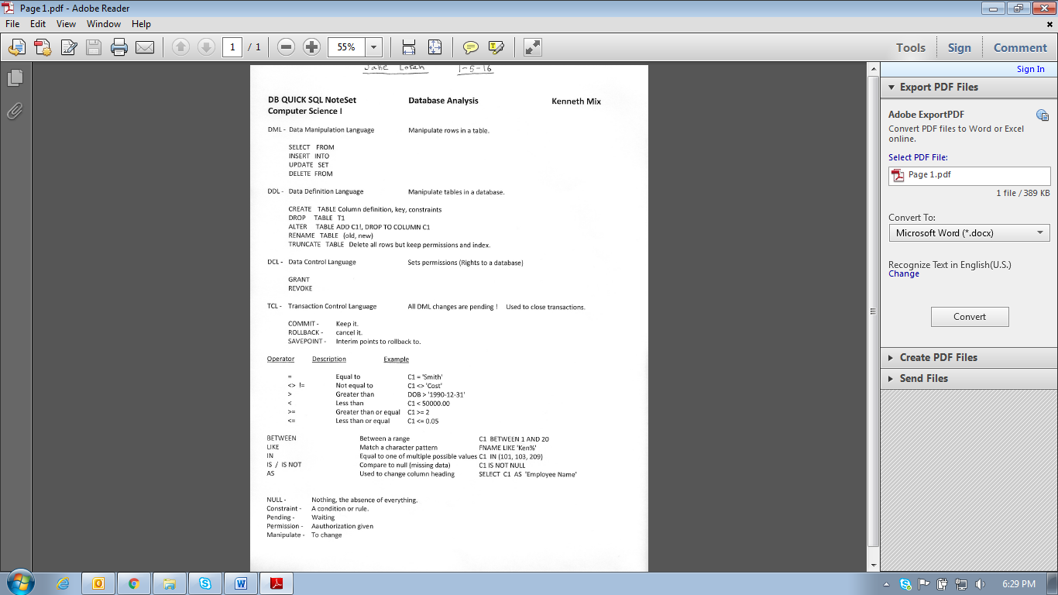Objective: Learn all about Database Analysis

**Page 1:**

**Page 2:**

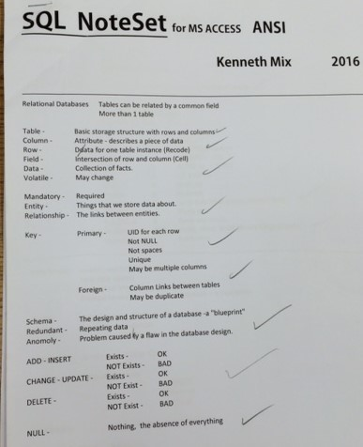

**Page 3:**

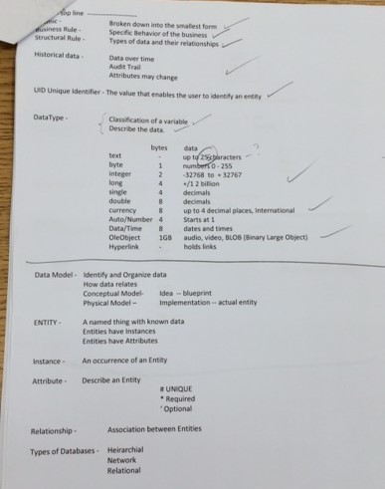

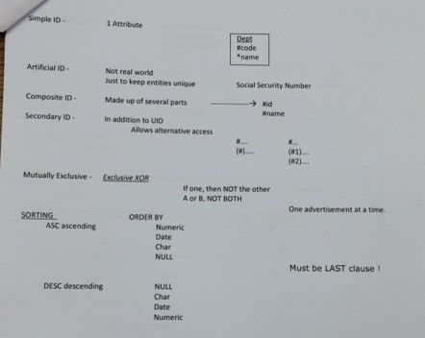**Page 4:**

**Lesson 1/5/16:**

Objective: Learn new vocabulary words

1. Table: A basic storage structure with rows and columns.
2. Column: Describes a piece of data (FNAME, LNAME).
3. Row: Data for one table instance.
4. Field: Intersection of a row and column (cell).
5. Data: Collection of facts.
6. Volatile: May change.
7. Mandatory: Required.
8. Entity: Things that we store data about.
9. Relationship: The links between entities.
10. Key: Two types are primary and foreign.
11. Primary Key: Unique identifier for each row. Can’t be null!
12. Foreign Key: A column link between tables. May be duplicates.
13. Schema: The design and structure of a database (blue print).
14. Anomaly: Problem caused by a flaw in the database design.
15. Atomic: Broken down into its smallest form.
16. Business rule: Specific behavior of a business.
17. Structural rule: The type of data and their relationships.
18. Historical data: Data over time. (Attributes may change).
19. Unique: One and only.
20. Unique identifier: One and only identifier.
21. Data types: Classification of a variable. Describes data.
22. OLE object: Audio, Video, and Blog.
23. Null: Optional.
24. Entity: A name thing with no data. Entities have instances. They have attributes.
25. Instance: Occurrence of an entity.
26. Attribute: Describes entity.
27. Data model: Used to identify and organize data.
28. Mutually exclusive: One or the other but not both.
29. Inner Join: Selects all the tables if there is a match.
30. BETWEEN: Range condition.
31. IN: List condition.
32. Constraint: A condition or a rule.
33. Pending: Waiting to happen.
34. Permission: Authorization given.
35. Manipulate: To change.

**Lesson 1/6/16:**

Objective: Learn the types of databases and Id’s

Types of databases:

* Hierarchical
* Network
* Relational

Types of Id’s:

* Simple Id: One attribute.
* Artificial Id: Not real world. Used just to keep uniqueness.
* Composite Id: Made up of several parts.
* Secondary Id: A column that is in addition to primary key.

**Lesson 1/7/16:**

Objective: Learn the different types of relationships

3 Types:

1. 1:1
2. 1:M
3. M:M

ERDISH:

Each Entity “A” Optionality Relationship Cardinality Entity “B”

2 Parts:

Optionality: Must (be) or (have)

May (be) or (have)

Cardinality: One

One or more

Example relationship:

1:1 = Employee Workstation

1:M = Department --------- <

M:M = Employee > <

**Lesson 1/13/16:**

Objective: Learn about the setup of a flowchart.

Statement

Function

Selection / Decision

Start & End

Connector

**Lesson 2/8/16:**

Objective: Start to dive into android.

1. Android: Open source mobile device operating system.
2. Intent: What needs to be done.
3. Activity: One screen.
4. UI: User Interface.
5. IDE: Integrated Developing Environment.
6. Surface: Object that holds pixels.
7. Bitmac: A wrapper for pixels.
8. Emulator: A virtual device.
9. Spinner: Drop down menu.
10. Widget: A component of a user interface.
11. View: The area of the screen for drawing and event handling.
12. Event handler: Executes when an event occurs.
13. Event: Clicking of a button.
14. MainActivity.java: Defines an application.
15. Activity_main.xml: Defines a layout.
16. R.java: Describes the resources of an application.
17. AndroidManifest.xml: Information about an application.
18. API (Application Programming Interface): The look, behavior, and libraries.
19. Build: Putting the moguls together into a .APK file.
20. Listener: Object that listens for an event.

**Lesson 2/24/16:**

Objective: Learn the three types of functions.

**String Functions:**

1. Concatenate.
2. Format (with strings)
3. Instr
4. LCase
5. Len
6. LTrim
7. Mid
8. Replace
9. RTrim
10. Str
11. StrComp
12. Trim
13. UCase

**Numeric Functions:**

1. Avg
2. Count
3. Format (with numbers)
4. Int
5. Max
6. Min
7. Randomize
8. Rnd (random number)
9. Round
10. Sqr
11. Sum
12. Val

**Date and Time Functions:**

1. Date
2. DateAdd
3. DateDiff
4. Day
5. Format (with Dates)
6. Hour
7. Minute
8. Month
9. MonthName
10. Now
11. Time
12. Weekday
13. WeekdayName
14. Year

**Lesson 3/17/16:**

Objective: Learn SQL Insert, Delete, and Update tags.

**Insert:**

Ex #1: Insert a new row: Employee_ID = 7001

SQL: INSERT INTO T2 (Employee_ID)

VALUES (7001);

Ex #2: Insert a new row: Employee_ID = 7002, John Smith

SQL: INSERT INTO T2 (Employee_ID, FirstName, LastName)

VALUES (7002, “John”, “Smith”);

**Delete:**

Delete all rows in table 2:

DELETE

FROM T2;

Delete only a specific row:

DELETE

FROM T2

WHERE C2 = 1234;

**Update:**

Ex #1: Update 7001 – Manager 244

SQL: UPDATE T2

SET Manager_ID = 244

WHERE Employee_ID = 7001;

Ex #2: Update 206 – add 2500 to existing salary

SQL: UPDATE T2

SET Salary = Salary + 2500

WHERE Employee_ID = 206;

**Lesson 4/11/16:**

Objective: Learn different types of memory and The Machine Cycle

**CPU (Control Processing Unit):**

* “The Brain” or “The Chip”
* The Control Unit.
* Arithmetic logic unit.

**CACHE:**

* Keeps most frequently used instructions.

**RAM (Random Access Memory):**

* Requires power.
* Temporary.

**SSD (Solid State Drive):**

* Faster.
* Less Heat.
* Less Power.
* No Moving Parts.
* More Reliable.
* More Expensive.
* Less Weight.
* Not Magnetic.
* Fast Seek Time.

**HDD (Hard Disk Drive):**

* Opposite of Solid State Drive

**Machine Cycle:**

1. Fetch.
2. Decode.
3. Execute.
4. Store.

**Lesson 5/17/16:**

Objective: Learn C++ coding

Task:

A = 3

B = 2

C = a+b

TOTAL = XX

EOJ

int main ()

{

C1 object 1;

Object 1.input();

Object 1.process();

Object 1.output();

}

**3.**

**2.**

**1.**

C1::C1()

{

a = 0;

b = 0;

c = 0;

}

void C1:: input()

{

a = 3;

b = 2;

}

void C1:: process()

{

c = a + b;

}

void C1:: output()

{

cout<<“TOTAL”<<c;

cout<<”IN”;

cout<<”EOJ”;

}

C1::~C1()

{

a = o;

b = 0;

c = 0;

}

Class C1

{

Public:

C1()

void input ();

void process();

void output();

~ C1 ();

Private:

int a;

int b;

int c;

};

**Lesson 5/23/16:**

Objective: Intro to Java.

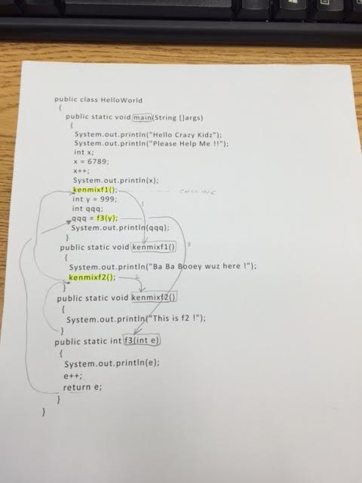

**Lesson 5/24/16:**

Objective: Private C++ lesson.

